The fatigue strength of a shaft is to be determined experimentally. At the test-setup, this shaft is supported on bearings. At the inlet part of this shaft power P is introduced at a rotational speed of n. There is no shear force at the inlet point. At the output end, friction brakes are applied. Additionally, the shaft experiences a centrifugal force due to unbalance mass m and a stationary force F.
As the shaft rotates, the resulting centrifugal force due to the unbalance mass will experience a change in direction. First in positive y-direction, then in the negative z-direction, then in the negative y-direction, then in the positive z-direction and back to positive y-direction for a complete rotation of the shaft.
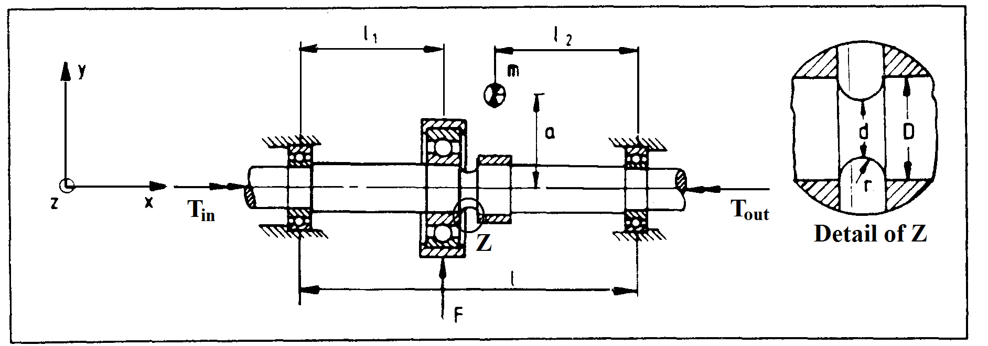
Data:
P=20 kW
n=2000rev/min
F=2500N
m=0.5kg
N=10⁷cycles
Geometry:
Material: St 50, Surface finish=polished
- How long must this shaft run on the test setup assuming a normal fatigue strength test is to undergo 10⁷ cycles (rotations)?
- Provide a quantitative graph of the bending moment of the shaft in the x-y plane for the following position of the unbalanced mass:
- Mass m in positive y-direction,
- Mass m in negative z-direction
- Mass m in negative y-direction, and
- Mass m in positive z-direction
- Provide a quantitative graph of the bending moment of the shaft in the x-z plane for the following position of the unbalanced mass:
- Mass m in positive y-direction,
- Mass m in negative z-direction
- Mass m in negative y-direction
- Mass m in positive z-direction
- The critical section of this shaft is identified to be at Z, where a groove has been cut. The detail of the groove is shown on the right side of the figure. What is the magnitude of the resultant bending moment at Z as the shaft makes a single rotation:
- Mass m in positive y-direction,
- Mass m in negative z-direction
- Mass m in negative y-direction, and
- Mass m in positive z-direction

- kk

